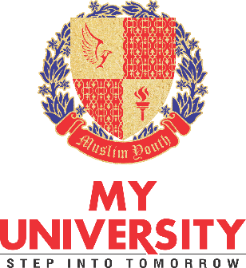

As per instruction of competent authority, please fill the following information and send it back to zawar.ahmed@myu.edu.pk so that your bio data at website of MY University should be updated.
- *Name:
- *Designation / Department:
- *Degree Level:
- *Bio, Objective, Achievements and awards:
- Facebook Address
- Twitter Address

- Attach one photograph in the email.

Best regards
Zawar Ahmad
Web/graphics Designer
MY University, Islamabad

+92 (300) 8859 668
+92 (51) 8733217-18 (8018)

