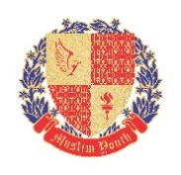

Request for Official Identity Card
Name: ________________________________________________________________________
Designation: ___________________________________________________________________
Department: ___________________________________________________________________
Date of Joining: _________________________________________________________________
CNIC No. ______________________________________________________________________
Blood Group: ___________________________________________________________________
Emergency Contact No. __________________________________________________________
Street Address: _________________________________________________________________
Please attach one photograph if not have any photograph in hard form then email a soft copy to zawar.ahmed@myu.edu.pk or WhatsApp at: 0300 8859668

Request for Official Identity Card
Name: ________________________________________________________________________
Designation: ___________________________________________________________________
Department: ___________________________________________________________________
Date of Joining: _________________________________________________________________
CNIC No. ______________________________________________________________________
Blood Group: ___________________________________________________________________
Emergency Contact No. __________________________________________________________
Street Address: _________________________________________________________________
Please attach one photograph if not have any photograph in hard form then email a soft copy to zawar.ahmed@myu.edu.pk or WhatsApp at: 0300 8859668

